
Active Copper (ACC) Cable
TECHNICAL DATA SHEET
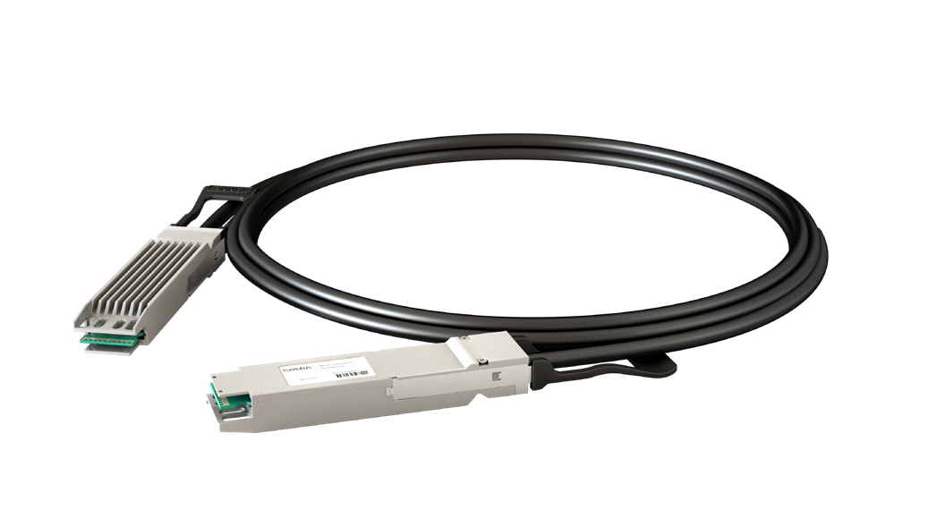
OSFP 400G to OSFP 400G ACC
2.5~5.0M PVC Black

Key Features
- Support 8x56G PAM4
- 400G To 400G Data Rate
- 3.3V Power Supply
- Hot Pluggable
- Excellent SI Performance
- Efficient Patching
- RoHS Compliance

Applications

- Data Center & Networking Equipment
- Servers/Storage Devices
- High Performance Computing (HPC)
- Switches/Routers
- Telecom Central Offices

Supported Standards
- OSFP MSA Rev 4.1
- IEEE 802.3cd
- IEEE 802.3bj
- I2C for EEPROM
- CMIS 5.0

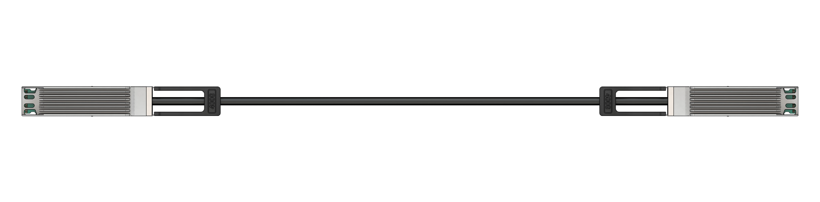

Ordering Information

LFOO-PK1xxxC | OSFP 400G to OSFP 400G ACC | — 2.5~5.0M
Ordering P/Ns | Description | Length | AWG | Cable | NOTE
LFOO-PK1x25C | OSFP 400G to OSFP 400G ACC | 2.5m | 30 AWG | PVC Black
LFOO-PK1x35C | OSFP 400G to OSFP 400G ACC | 3.5m | 28 AWG | PVC Black
LFOO-PK1x50C | OSFP 400G to OSFP 400G ACC | 5.0m | 26 AWG | PVC Black
xxx define ACC cable length

www.lumulus.com 9685 Via Excelencia, San Diego, CA 92126 Rev.A—14/04/2026
1
Images are for illustrative purposes only and may not accurately represent the actual product. Specifications and appearances are subject to change without prior notice.

Description
The LFOO-PK1xxxC, OSFP 400G Active Redriver Copper Cable Assembly, meticulously designed for application in the tele-communications and data center sectors. It facilitates bidirectional transmission of 400Gb traffic per cable, accommoda-ting 8 lanes of 50G PAM4. The cable adheres to the standardized OSFP form factor and complies rigorously with MultiSour-ce Agreement (MSA) specifications.

Absolute Maximum Ratings
Parameter | Unit | Min. | Max. | Notes
Supply Voltage | V | -0.3 | 3.6
Data Input Voltage | V | -0.3 | 3.6
Control Input Voltage | V | -0.3 | 3.6
Operating Temperature | °C | 0 | 70
Storage Temperature | °C | -40 | +85
Relative Humidity (NonCondensing) | % | 5 | 85

Operational Specification
Parameter | Unit | Min | Typical | Max | Notes
Supply Voltage (Vcc) | V | 3.135 | 3.3 | 3.465 | Per End
Power Consumption | W |  |  | 1.5 | Per End
Operating Case Temperature | °C | 0 |  | 70
Operating Relative Humidity | % | 0 |  | 85
Modulation Format |  |  | 56G PAM4
Bit Rate | Gbps | 8x50G to 8x50G

Electrical Characteristics
Parameter | Unit | Min | Typical | Max | Notes
Characteristic Impedance | ohm | 90 | 100 | 110
Time Propagation Delay (Informative) | ns | ….. | ….. | 4.9

SI Performance
Item | Parameter | Require | Reference
1 | ILdd Insertion loss at 13.28 GHz | 17.16 dB (Max.) | IEEE 802.3cd Section Section 136.11.2
2 | ILdd Insertion loss at 13.28 GHz | 8 dB (Min.) | IEEE 802.3cd Section Section 136.11.2
3 | ERL  Minimum cable assembly | >11 dB*. | IEEE 802.3cd Section Section 136.11.3
4 | RLcd Differentialmode to commonmode return loss | 0.01GHz – 19GHz Equation (92–28) | IEEE 802.3cd Section 136.11.4
5 | ILcd Differentialmode to commonmode insertion loss | 0.01GHz – 19GHz Equation (92–29) | IEEE 802.3cd Section 136.11.5
6 | RLcc Commonmode to commonmode return loss | 0.01GHz – 19GHz Equation (92–30) | IEEE 802.3cd Section Section 136.11.6
7 | COM | 3dB (Min.) | IEEE 802.3ck Section 162.11.7
*Cable assemblies with a com greater than 4 dB are not required to meet minimum ERL

Cable Wiring
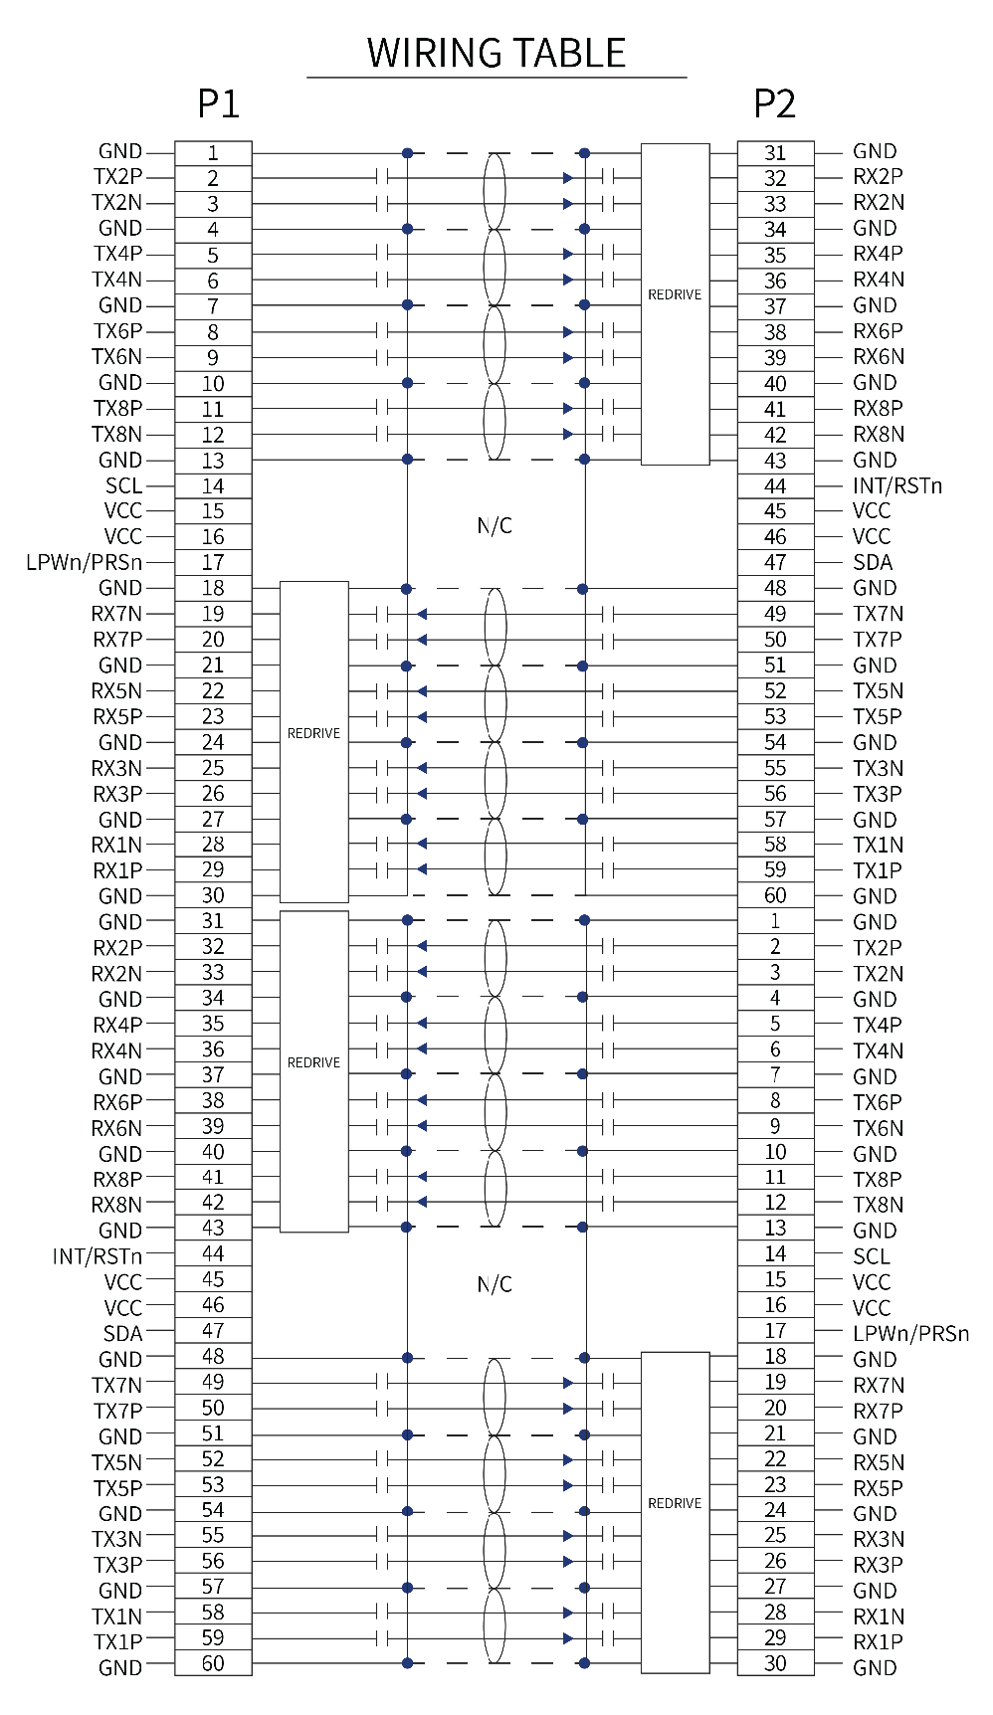

OSFP 400G Active Redriver Cable Assembly Wiring

Memory Map information (CMIS Version)

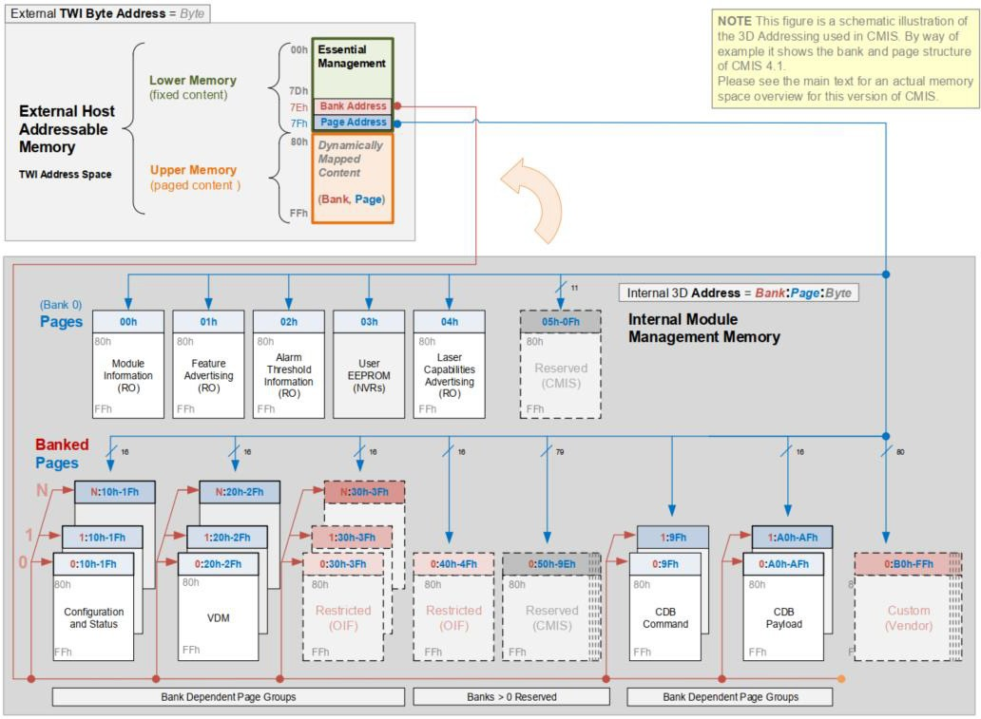

Lower Memory Overview
Address | Size | Subject Area | Description
0-3 | 4 | ID and Status Area | Module ID from SFF8024 list, version number, Type and status
0-3 | 4 | ID and Status Area | Flat mem indication, CLEI present indicator, Maximum TWI speed, Current state of Module, Current state of the Interrupt signal
4-7 | 4 | Lane Flag Summary | Flag summary of all lane flags on pages 10h1Fh
8-13 | 6 | ModuleLevel Flags | All flags that are not lane or data path specific
14-25 | 12 | ModuleLevel Monitors | Monitors that are not lane or data path spedific
26-30 | 5 | Module Global Controls | Controls applicable to the module as a whole
31-36 | 6 | ModuleLevel Flag Masks | Masking bits for the ModuleLevel flags
37-38 | 2 | CDB Status Area | Status of most recent CDB command

39-40 | 2 | Module Firmware Version | Module Firmware Version
41-63 | 23 | Reserved Area | Reserved for future standardization
64-82 | 19 | Custom Area | Vendor or module type specific use
83-84 | 2 | Inactive Firmware Version | Version Number of Inactive Firmware. Values of 00h  indicates module supports only a single image.
85-117 | 33 | Application Advertising | Combinations of host and media interfaces that are supported by module data path(s）
118-125 | 8 | Password Entry and Change
126 | 1 | Bank Select Byte | Bank address of currently visible Page
127 | 1 | Page Select Byte | Page address of currently visible Page

Page 00h Overview
Address | Size (bytes) | Name | Description
128 | 1 | Identifier | Identifier Type of module
129-144 | 16 | Vendor name | Vendor name (ASCII)
145-147 | 3 | Vendor OUI | Vendor IEEE company ID
148-163 | 16 | Vendor PN | Part number provided by vendor (ASCII)
164-165 | 2 | Vendor rev | Revision level for part number provided by vendor (ASCII)
166-181 | 16 | Vendor SN | Vendor Serial Number (ASCII)
182-189 | 8 | Date Code
190-199 | 10 | CLEI code | Common Language Equipment Identification code
200-201 | 2 | Module power characteristics
202 | 1 | Cable assembly length
203 | 1 | Media Connector Type
204-209 | 6 | Copper Cable Attenuation
210-211 | 2 | Cable Assembly Lane Information
212 | 1 | Media Interface Technology
213-220 | 8 | Reserved
221 | 1 | Custom
222 | 1 | Checksum | Includes bytes 128221
223-255 | 33 | Custom Info NV
Note: For the above, refer to Common Management Interface Specification Rev5.0.

Mechanical Specifications
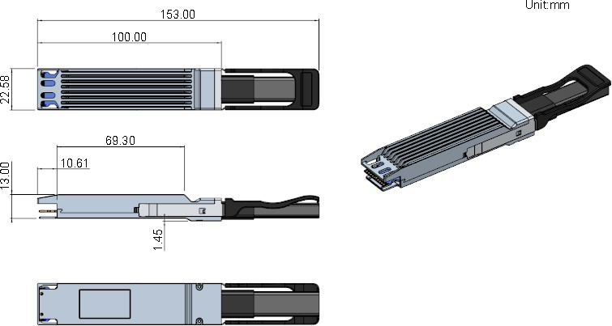

OSFP Form Factor

OSFP PIN Function Definitions

Pin | Logic | Symbol | Description
1 |  | GND | Ground
2 | CML-I | Tx2p | Transmitter Data Non-Inverted
3 | CML-I | Tx2n | Transmitter Data Inverted
4 |  | GND | Ground
5 | CML-I | Tx4p | Transmitter Data Non-Inverted
6 | CML-I | Tx4n | Transmitter Data Inverted
7 |  | GND | Ground
8 | CML-I | Tx6p | Transmitter Data Non-Inverted
9 | CML-I | Tx6n | Transmitter Data Inverted
10 |  | GND | Ground
11 | CML-I | Tx8p | Transmitter Data Non-Inverted
12 | CML-I | Tx8n | Transmitter Data Inverted
13 |  | GND | Ground
14 | LVCMOS-I/O | SCL | 2-wire serial interface clock
15 |  | VCC | +3.3V Power
16 |  | VCC | +3.3V Power
17 | Multi-Level | LPWn/PRSn | Low-Power Mode / Module Present
18 |  | GND | Ground
19 | CML-O | Rx7n | Receiver Data Inverted
20 | CML-O | Rx7p | Receiver Data Non-Inverted
21 |  | GND | Ground
22 | CML-O | Rx5n | Receiver Data Inverted
23 | CML-O | Rx5p | Receiver Data Non-Inverted

24 |  | GND | Ground
25 | CML-O | Rx3n | Receiver Data Inverted
26 | CML-O | Rx3p | Receiver Data Non-Inverted
27 |  | GND | Ground
28 | CML-O | Rx1n | Receiver Data Inverted
29 | CML-O | Rx1p | Receiver Data Non-Inverted
30 |  | GND | Ground
31 |  | GND | Ground
32 | CML-O | Rx2p | Receiver Data Non-Inverted
33 | CML-O | Rx2n | Receiver Data Inverted
34 |  | GND | Ground
35 | CML-O | Rx4p | Receiver Data Non-Inverted
36 | CML-O | Rx4n | Receiver Data Inverted
37 |  | GND | Ground
38 | CML-O | Rx6p | Receiver Data Non-Inverted
39 | CML-O | Rx6n | Receiver Data Inverted
40 |  | GND | Ground
41 | CML-O | Rx8p | Receiver Data Non-Inverted
42 | CML-O | Rx8n | Receiver Data Inverted
43 |  | GND | Ground
44 | Multi-Level | INT/RSTn | Module Interrupt / Module Reset
45 |  | VCC | +3.3V Power
46 |  | VCC | +3.3V Power
47 | LVCMOS—I/O | SDA | 2-wire serial interface data
48 |  | GND | Ground

49 | CML-I | Tx7n | Transmitter Data Inverted
50 | CML-I | Tx7p | Transmitter Data Non-Inverted
51 |  | GND | Ground
52 | CML-I | Tx5n | Transmitter Data Inverted
53 | CML-I | Tx5p | Transmitter Data Non-Inverted
54 |  | GND | Ground
55 | CML-I | Tx3n | Transmitter Data Inverted
56 | CML-I | Tx3p | Transmitter Data Non-Inverted
57 |  | GND | Ground
58 | CML-I | Tx1n | Transmitter Data Inverted
59 | CML-I | Tx1p | Transmitter Data Non-Inverted
60 |  | GND | Ground

OSFP Electrical Pad Layout
For detail mechanical information, please refer to the related document of OSFP MSA.
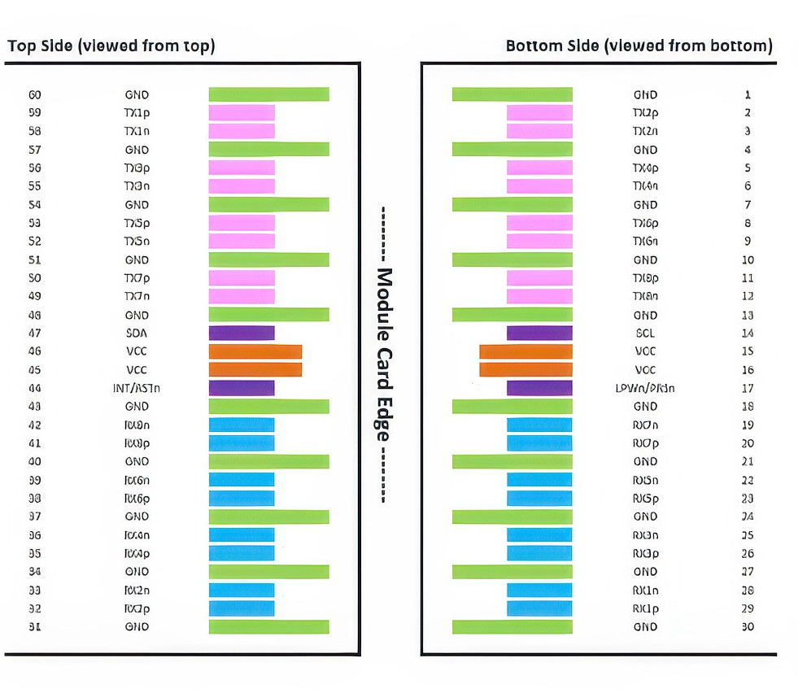

LFOO-PU1xxxC

Disclaimer

Images are for illustrative purposes only and may not accurately represent the actual
product. Specifications and appearances are subject to change without prior notice.
The information provided in this datasheet is subject to change without notice. Lumulus Technologies assumes no responsibility for any errors or omissions. Performance may vary depending on application and operating conditions. Product specifications are pro-vided for reference only and do not constitute a warranty.
For assistance and more information, please contact your sales representative or write
to sales@lumulus.com




Lumulus Technologies, Inc. USA Headquarter
9685 Via Excelencia Suite 106
San Diego, CA 92126 USA
(+1) 858-397-2228
www.lumulus.com
sales@lumulus.com

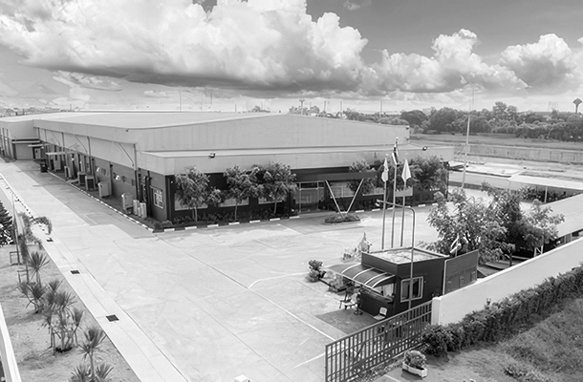
Lumulus Technologies, Inc. (Thailand Branch)

Production Site
30/30 Moo2, Tambol Wangchula Amphur, Wagnoi, Phranakorn
Sri Ayutthagya - 13170, Thailand

Lumulus Tech offers 24/7 support,
- with experts ready to assist with all your technical needs and questions.


 tech.support@lumulus.com sales@lumulus.com

www.lumulus.com 9685 Via Excelencia, San Diego, CA 92126 Rev.A—17/01/25 www.lumulus.com 9685 Via Excelencia, San Diego, CA 92126 Rev.A—14/04/2026
4
4

